## 

**FINAL PROJECT**

# E HEALTH CARE MANAGEMENT SYSTEM

**PROGRAMMING FUNDAMENTALS**

**DATE OF SUBMISSION**

22nd January 2023

**PREPARED FOR**

SIR UMAR IQBAL

**PREPARED BY**

SADIA IMRAN

SP22-BCS-087

## INTRODUCTION:

The management system of a hospital is the subject of this paper. This system has two modules ***patient and admin.*** signup and login feature where the patient enters his information and it is saved in a file. During the registration process, each patient receives a special ID. They have access to their entered data. Booking an emergency room and making a doctor's appointment are both choices. Three additional departments are available for doctor appointments. The patient might choose from among the available doctors. Three different types of rooms exist. Additionally, it computes various bills for rooms and appointments.

## **DETAILS AND RESULTS**

This project has various modules or features listed below:

### **PATIENT:**

#### LOGIN/SIGNUP:

* + *A screenshot of a computer

    Description automatically generated*The following patient information is accepted by this module: ***name, email, password, phone number, gender, age, room type, marital status, and a unique ID*** that is produced for every patient.
  + This data is ***permanently stored*** in a file until and unless admin himself delete patients’ data.

* + Patient can login anytime using his email and password.

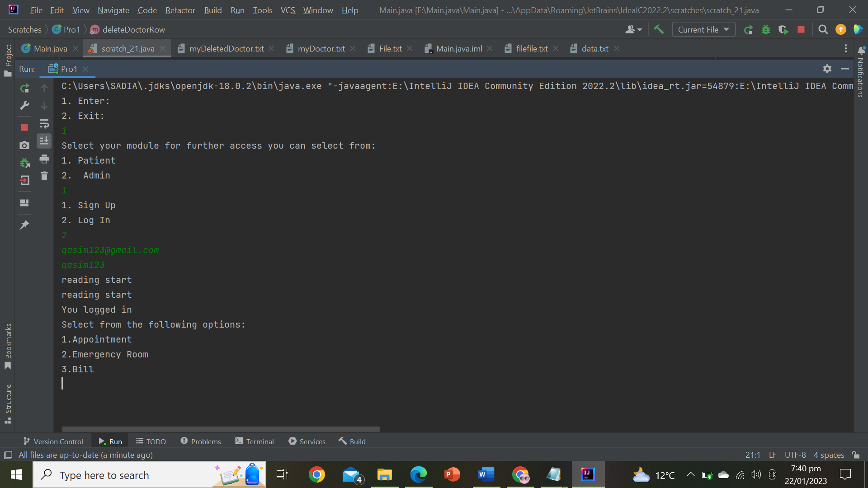

#### APPOINTMENT:

* This feature gives patient 3 departments to choose according to his disease i.e., ***Cardio, Ortho, Gyane, Physio.*** Each department have further 3 doctors available.

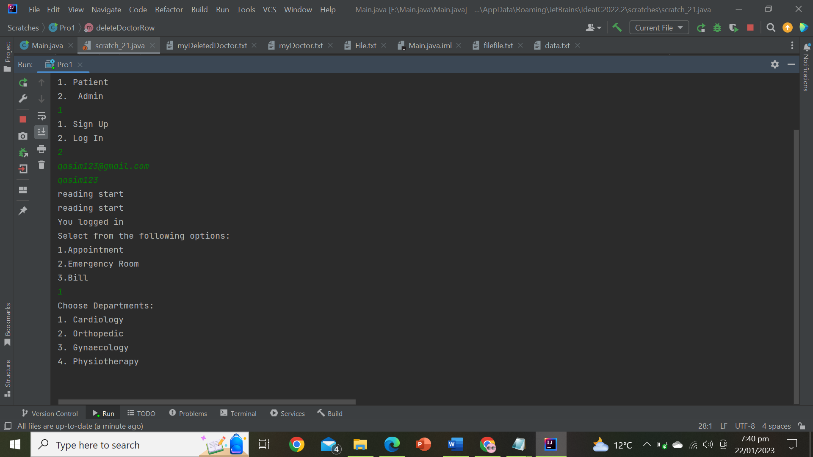

* If a patient makes an appointment with any of the available doctors, that doctor won't be available to the succeeding patient until the patient who made the appointment pays the bill.

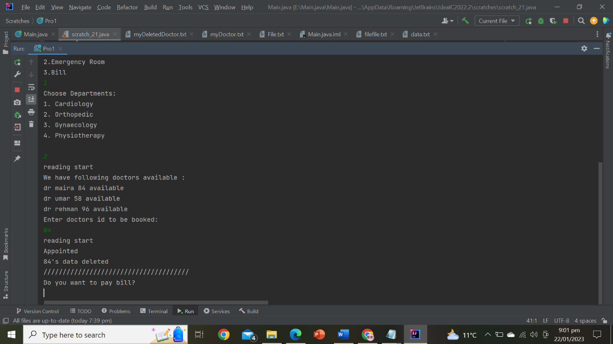

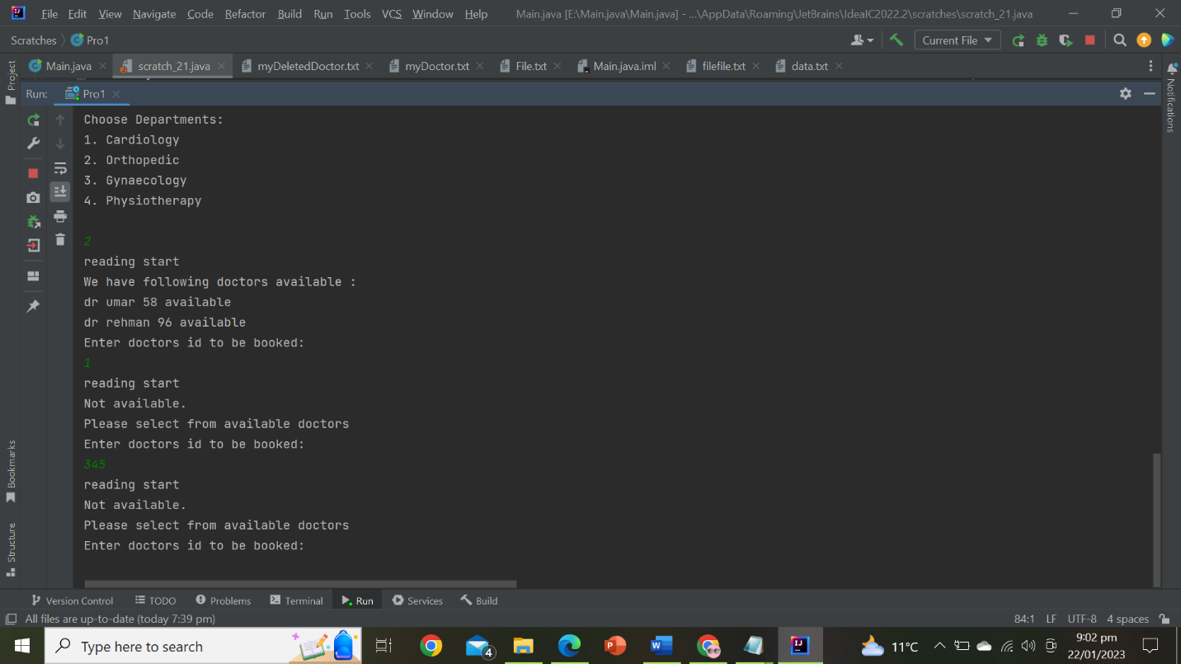

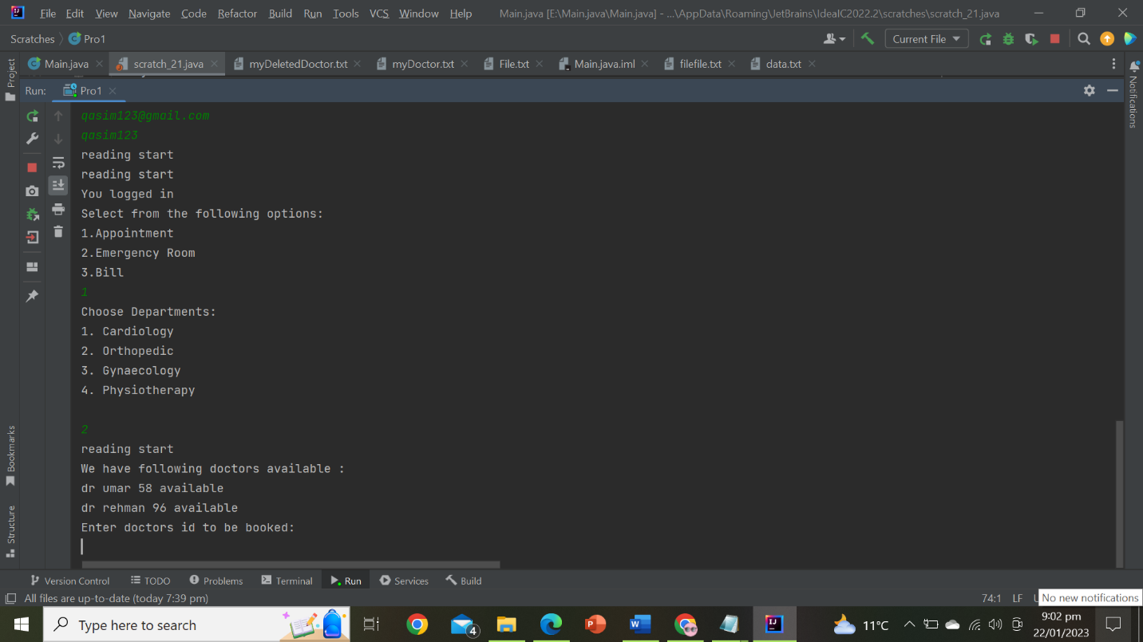

#### EMERGENCY ROOM:

* 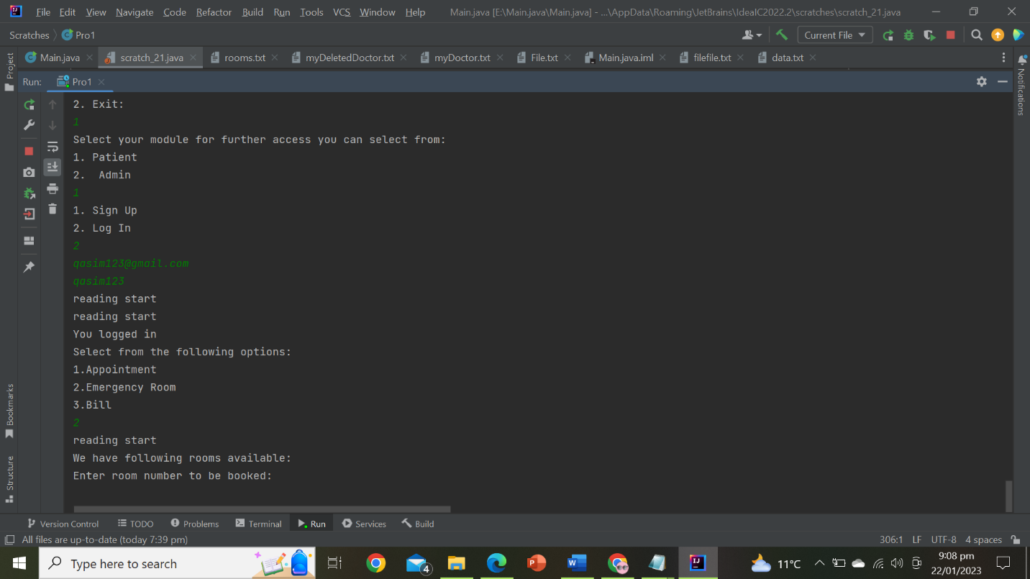This feature gives patient to book emergency room from the available rooms.

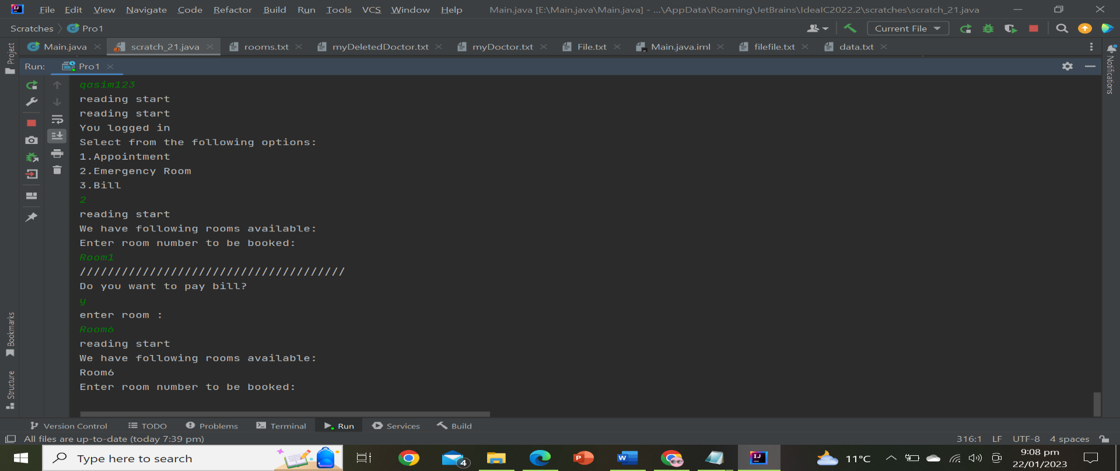

* There are further 2 categories of rooms i.e., Economy and Business.
* If patient book any of the room that room is not available to the next patient.

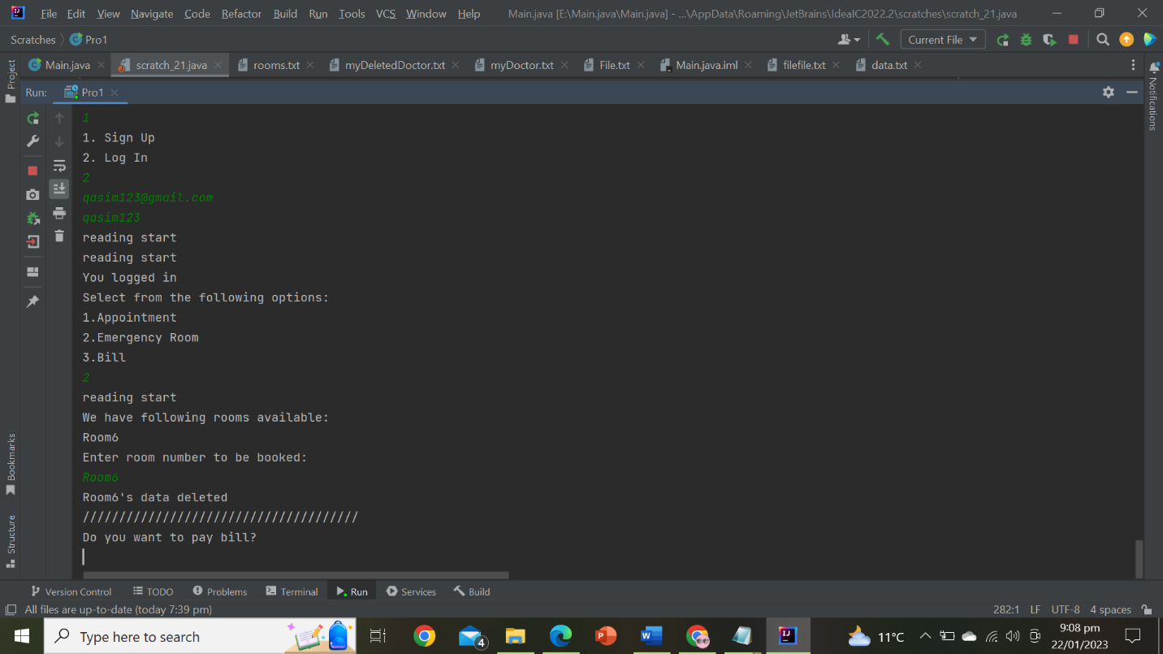

#### BILL PAYMENT:

* You have a choice between two options: ***bill for room and bill for appointment.***
* Each case has a different cost.
* The bill-paying tool requests the doctor's ID and the room number that have been reserved. After that, the availability was added back in along with the requested room and doctors.

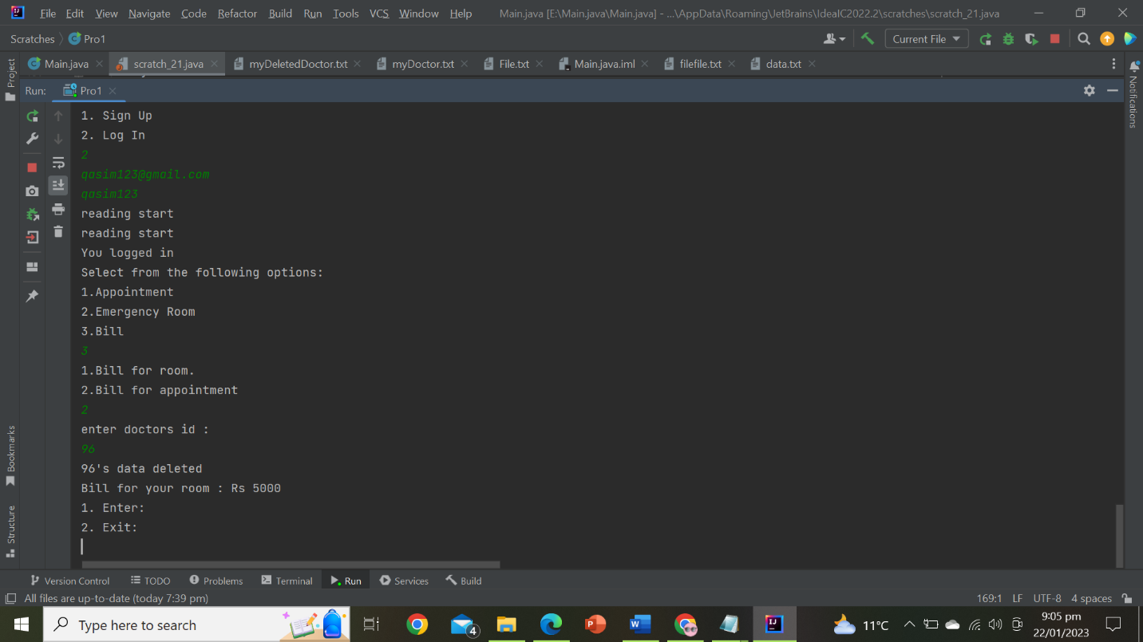

### **ADMIN:**

#### LOGIN:

No signup is available for admin. He can only log in if he provides the right email address and password; else, the computer will repeatedly request him for the inputs.

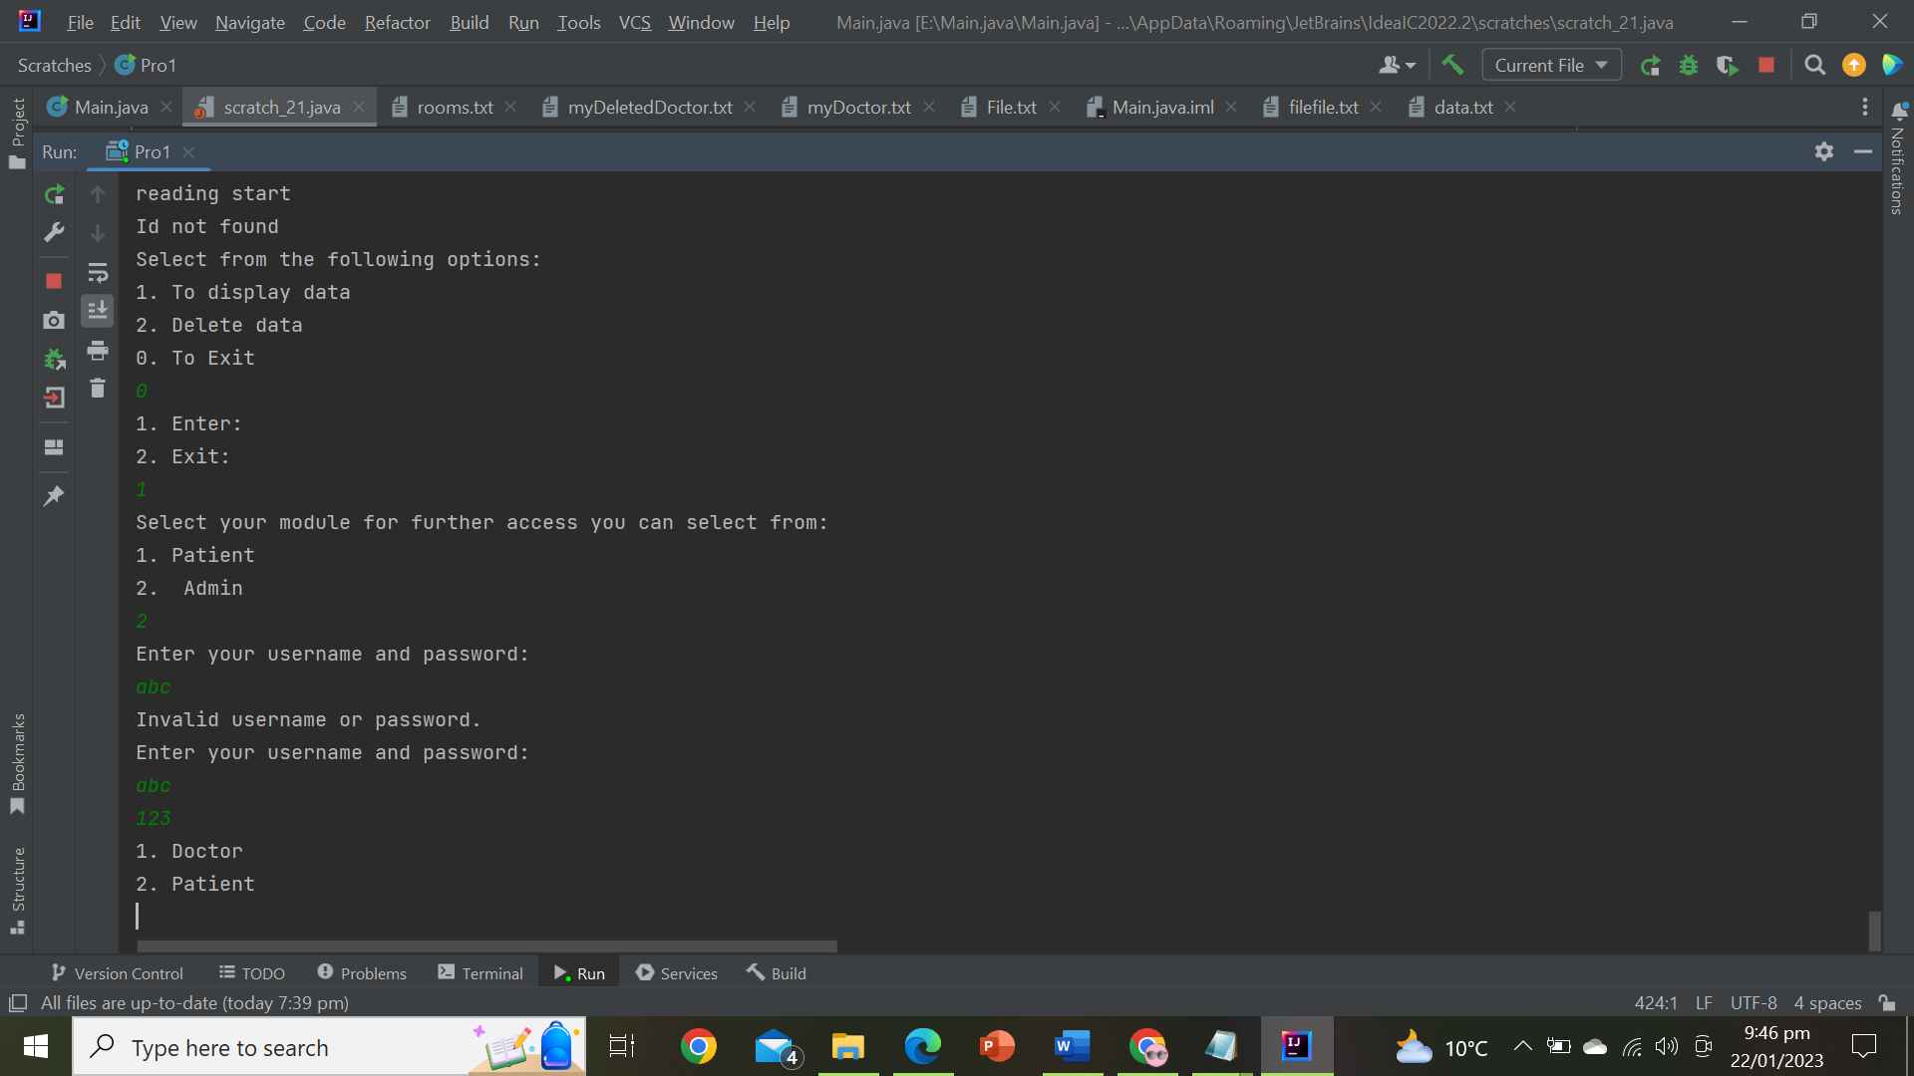

#### MANAGE DOCTORS DATA:

* The administrator can add new hired doctors' data to the appropriate department.

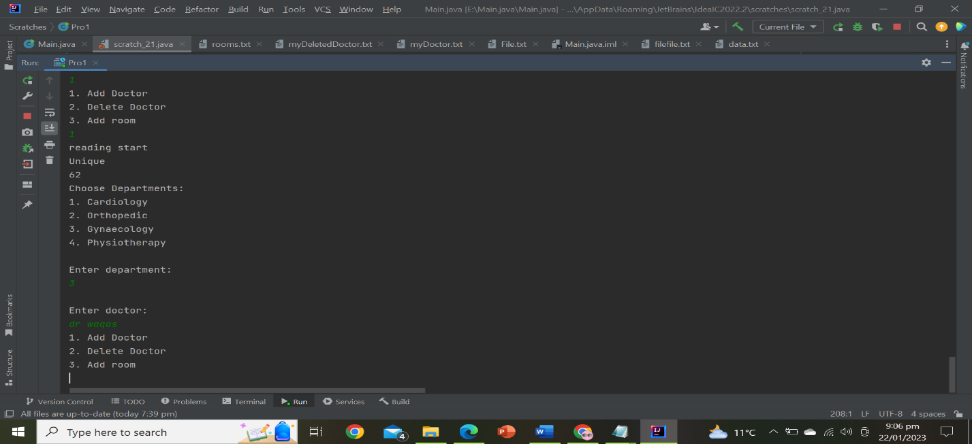

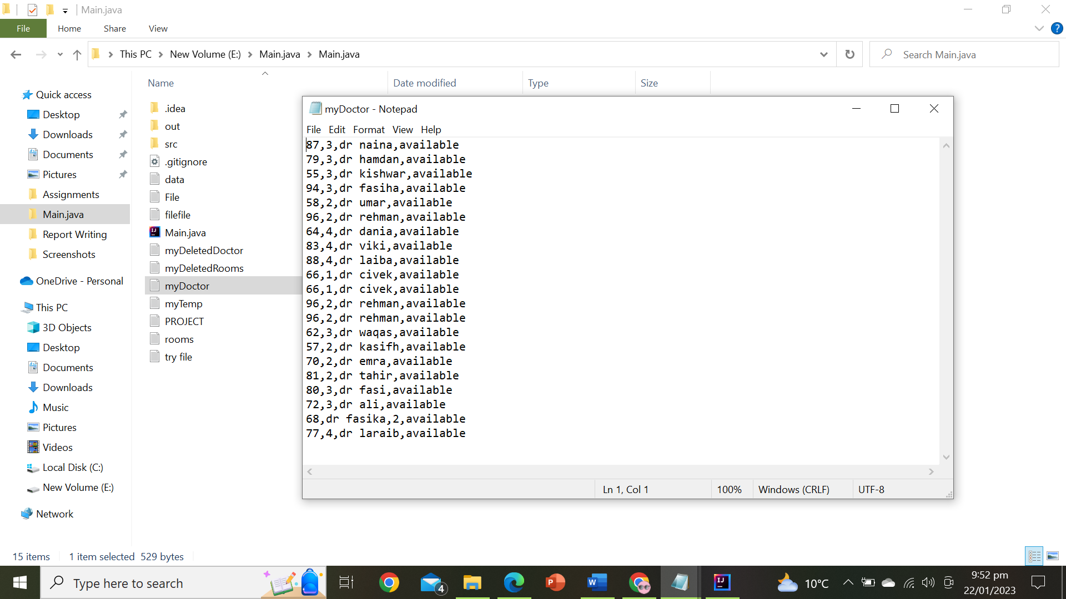

* He can remove any doctor's records.

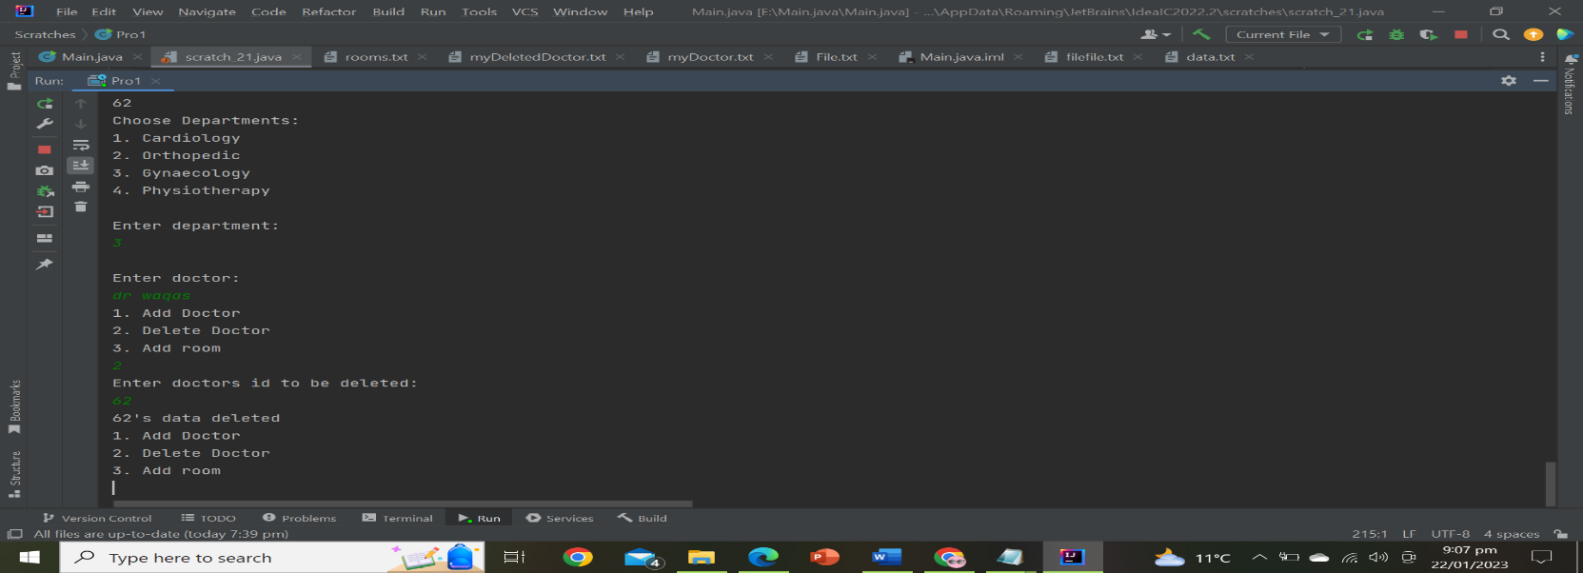

#### ADD ROOMS:

* 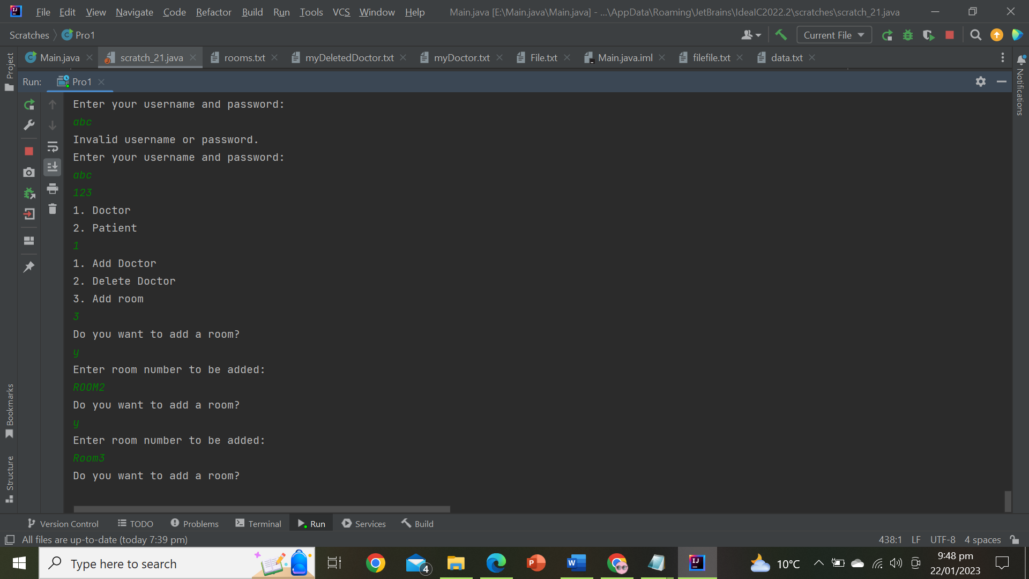Admin can add rooms.

#### MANAGE PATIENTS’ DATA:

* 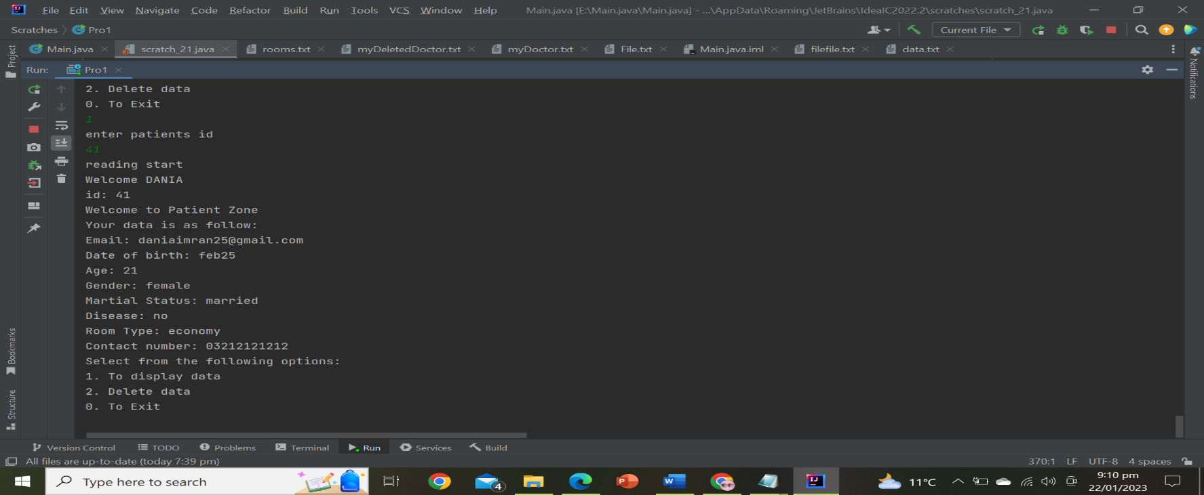Admin can display patients’ data and delete data.

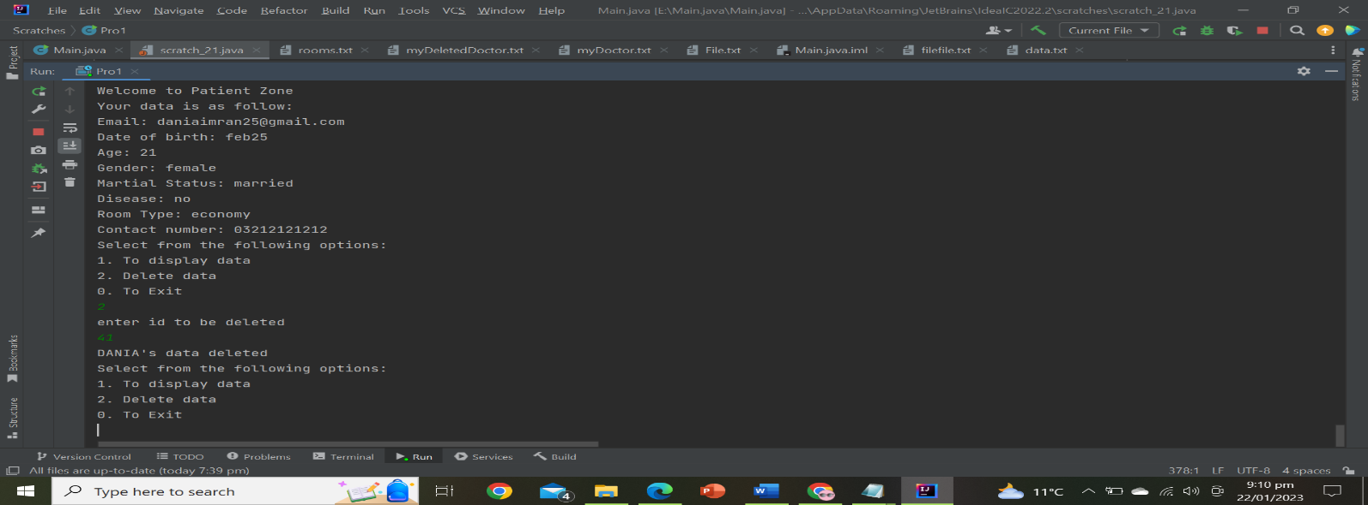

* When an administrator enters an invalid patient id number, the program repeatedly asking for a valid patient id number.

